Year 2 National Film and Sound Archives
DESCRIPTION:

Students will explore how media technologies have changed over time as part of their media arts unit in Performing Arts.

DATE: DEPARTING AT: RETURNING APPROX:

Friday, 5 May 2023 | 9.30 am | 12.00 pm

VENUE: TRAVEL ARRANGEMENTS:

National Film and Sound Archives  McCoy Circuit, Acton | Bus

COST PER STUDENT: CLASSES INVOLVED: TEACHER IN CHARGE:

$ 16.00 | 2JP, 2BP and 2S | Brittany Ashman

ITEMS TO BRING:

School uniform, enclosed shoes and a SunSmart to be worn.
Please bring fruit break and a drink bottle in a labelled shopping bag for the excursion.

ADDITIONAL INFORMATION: PAYMENT OPTIONS:

Pay using your credit/debit card by:
- Visiting the following link: www.monashps.act.edu.au/payment

- Follow the instructions on our Westpac Quickweb form, including the fee code: Yr 2 Film

Alternatively, you may wish to pay in person by EFTPOS at the Front Office.

A Risk Management Plan is available for this excursion upon request.

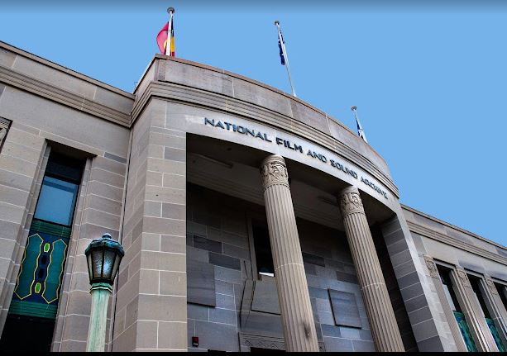

Please keep this information page, then complete the permission form and return it to the front office by Friday, 28 April 2023

Year 2 National Film and Sound Archives

PLEASE RETURN TO THE FRONT OFFICE BY Friday, 28 April 2023,

Student Name: |  | Class:
I hereby consent to my child attending the Year 2 National Film and Sound Archives Excursion on Friday, 5 May 2023.
Cost: $16.00 Code: Yr 2 Film
Please check the appropriate boxes:

I have read and understand the attached information page for the event/excursion, and I consent to the travel arrangements. PLEASE NOTE: If you fill in this form, your personal information and that of your child will be collected and handled by the ACT Education Directorate (ETD) (Monash School). This information is necessary for us to be able to manage student participation in excursions, and support the welfare and safety of your child. If you do not consent to supply us with this information your child will be unable to participate in the excursion.
The School should be notified by 9.00 am on the day of the excursion if a student is unable to attend.
I understand that the ACT Government (the Territory) does not meet all claims for injury, disease or illness to students resulting from school activities or school organised excursions. Claims are only met where there is a liability to do so. Liability is not automatic and depends on the circumstances in which the injury was sustained. I understand I should obtain my own advice about insurance protection which may assist in meeting expenses if my child is injured in circumstances where there is no liability on the part of the Territory. The ACT Ambulance Service provides free ambulance transport for students who are injured or suddenly become ill at school or during school-approved activities within the ACT. Excursions to states and territories outside the ACT are not covered by free ambulance transport.
In serious cases where medical attention is necessary, and a parent/carer is not available, I authorise the school to make arrangements for the welfare of my child (including transport and medical/surgical treatment).
I agree that my child/children will be under the authority of the school for the duration of the excursion and that the school is authorised to return the student home at the expense of the parent/carer if the school considers that circumstances warrant such action.
The medical information and emergency contact numbers for my child/children held at the school are correct and up to date.
I need to UPDATE the information held at the school as follows: (ONLY FILL IN IF THE SCHOOL DOES NOT HAVE THIS INFORMATION)
Parent/Carer Phone No.
Parent/Carer Phone No.
Home Telephone Number:
Please change my “Other Emergency Contact” to: (please include full name and contact number)

Full Name of Parent/Carer: |  | Date:

